CS 255 System Design Document Template

UML Diagrams

UML Use Case Diagram
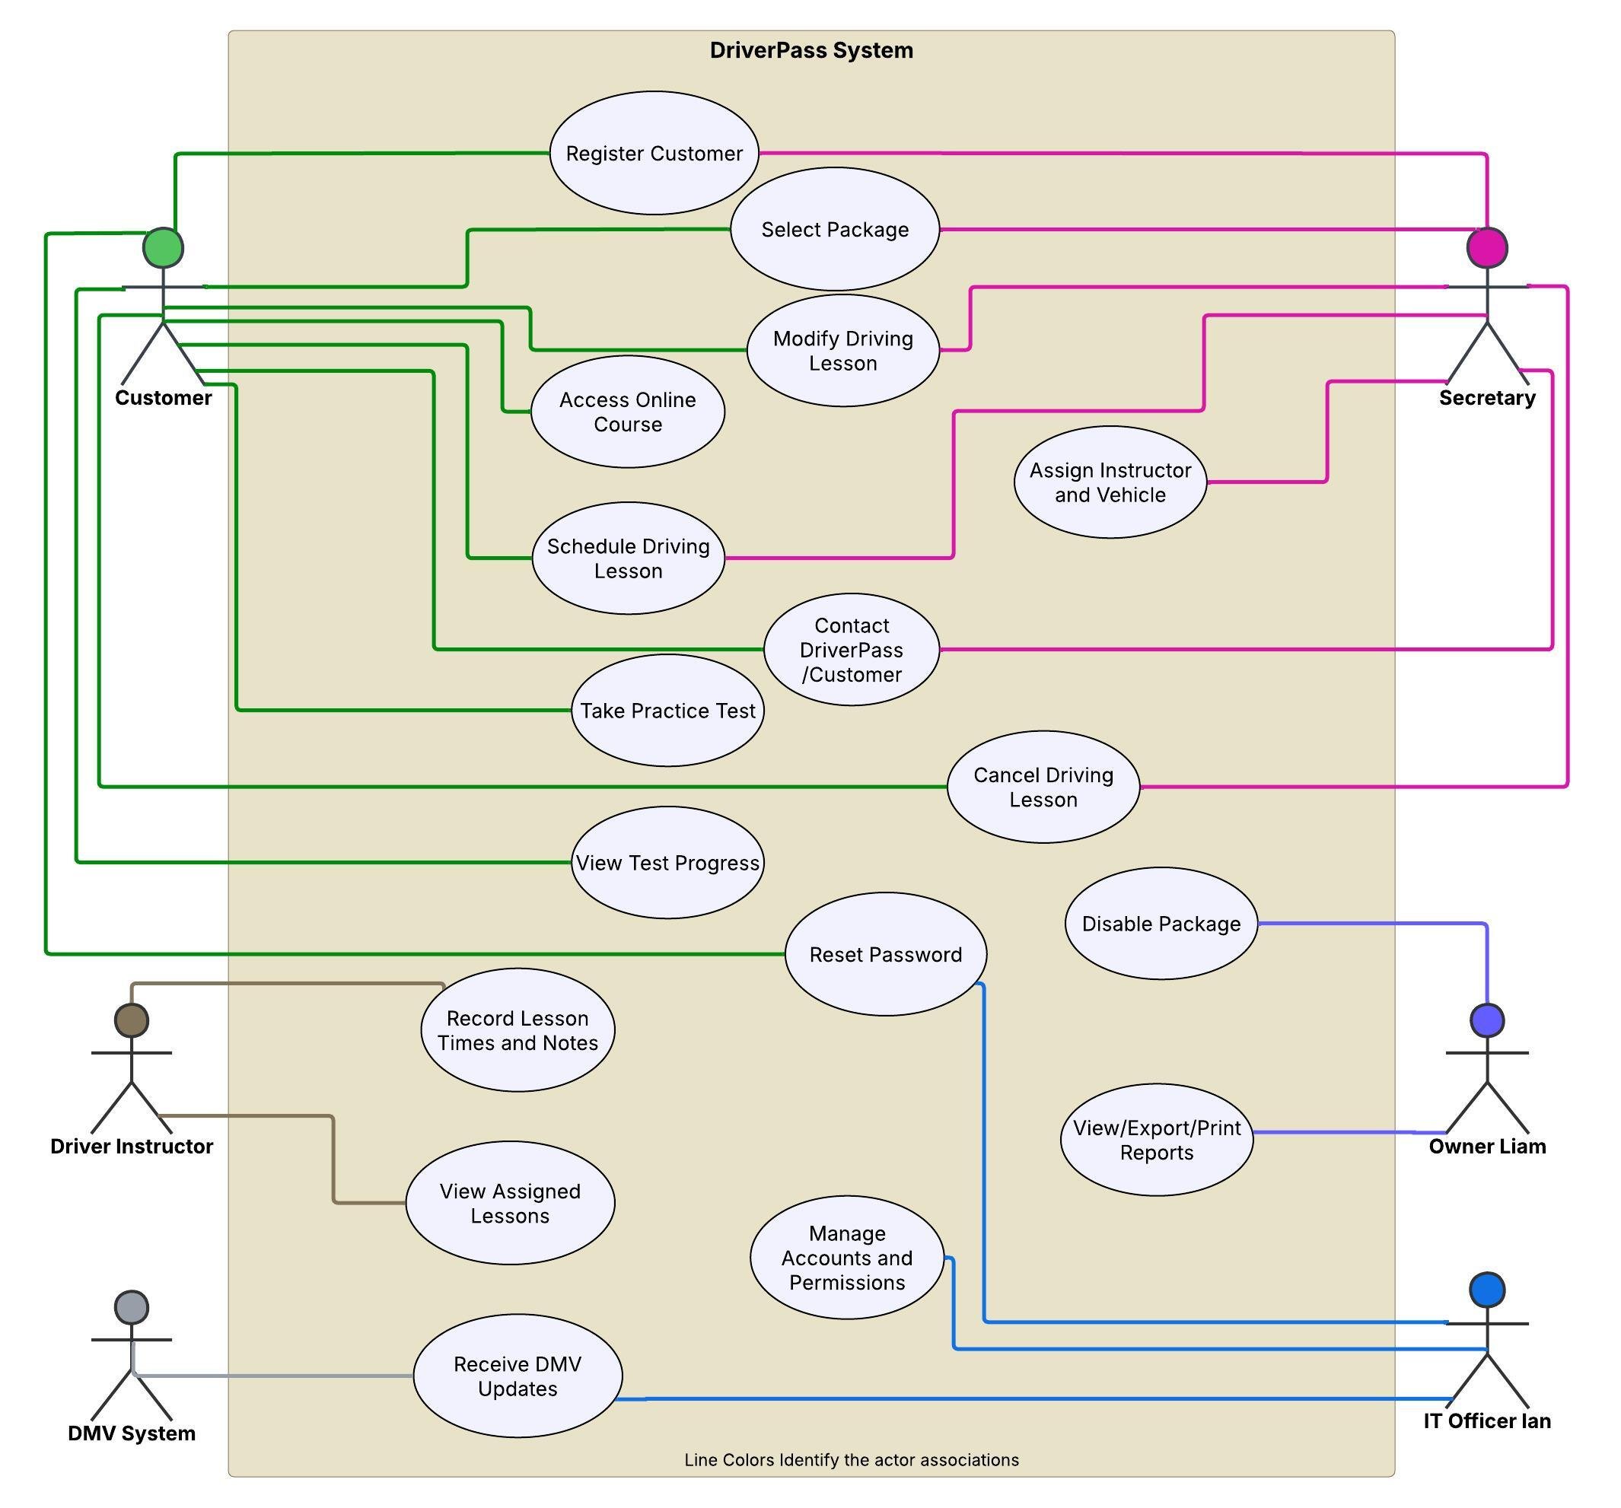

UML Activity Diagrams

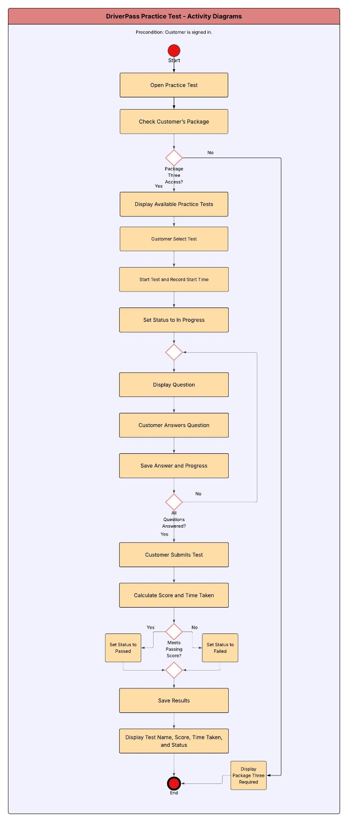
UML Activity Diagrams
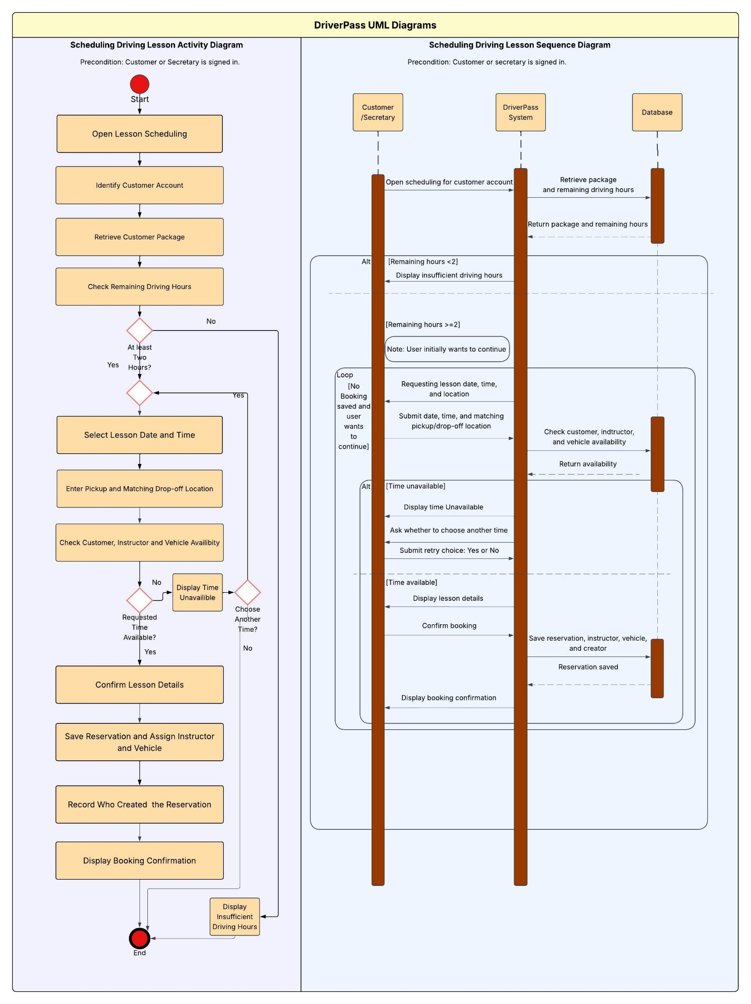
UML Sequence Diagram

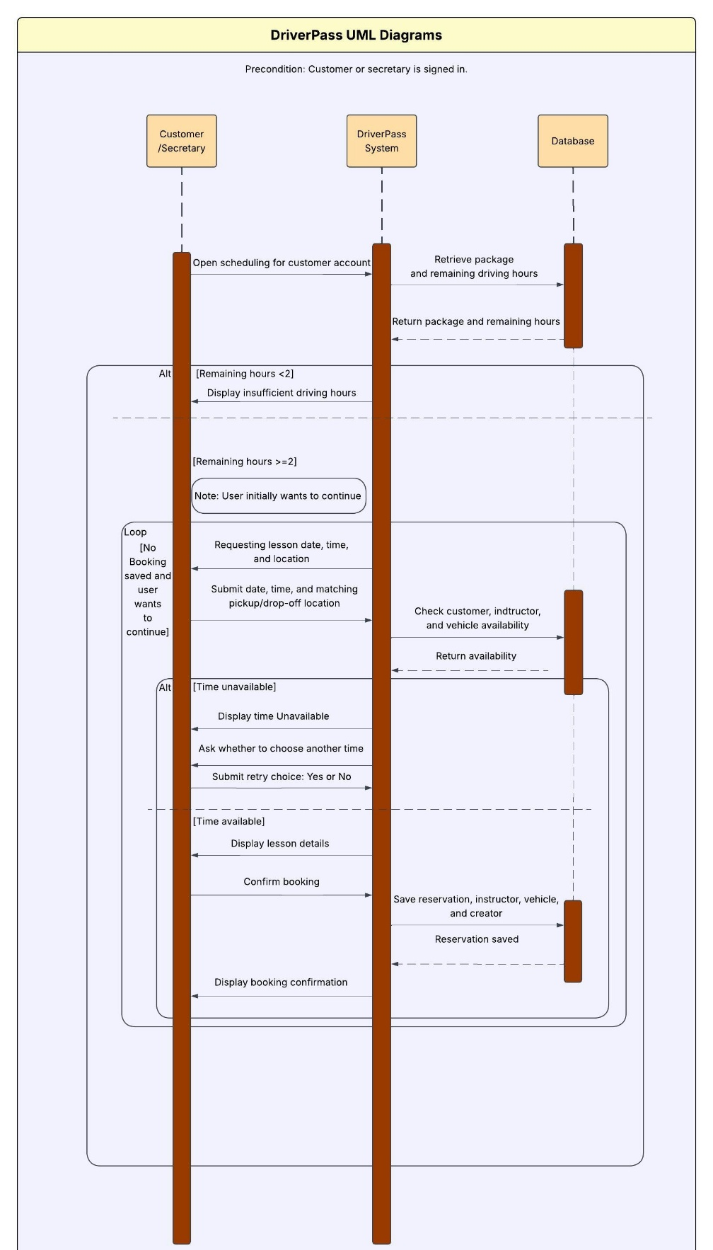

UML Class Diagram
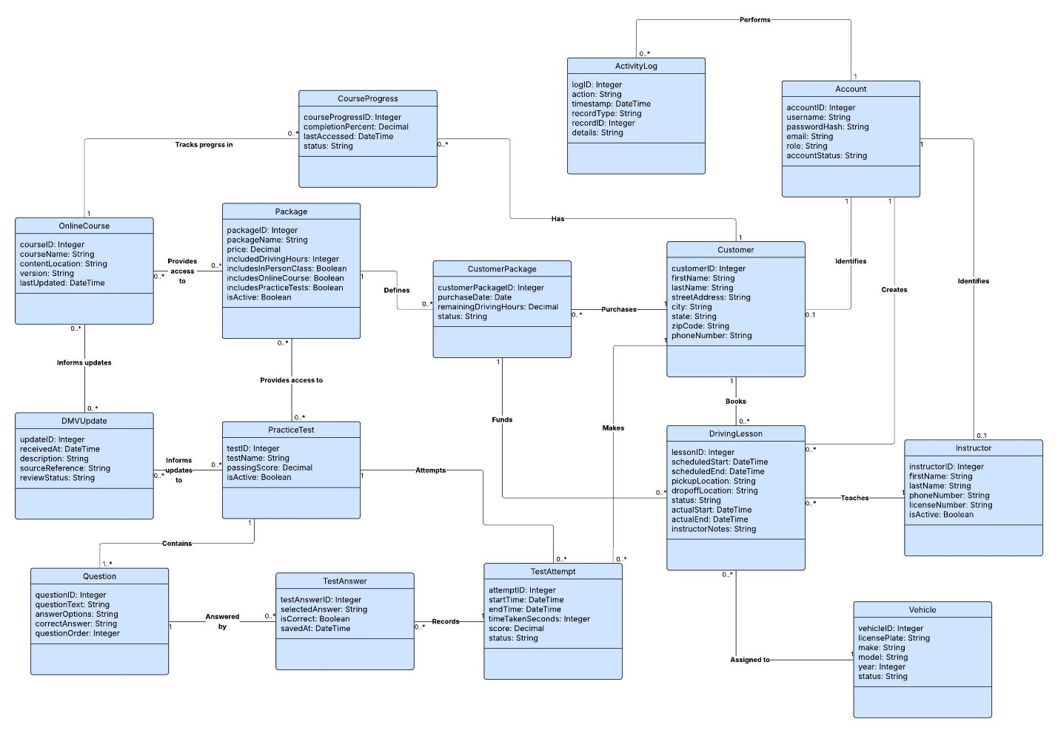
Technical Requirements
DriverPass will use a cloud hosted web application that customers and employees can access through a computer or mobile devices. Users will need an internet connection to create accounts, make or change reservations, access online learning materials, and update account details. Employees will need office computers and access to a printer for reports. Cloud hosting will allow everyone to work with the same updated information instead of keeping separate records on individual computers.
I propose using Linux as the server operating system and PostgreSQL, a relational SQL database, to store the system’s records. This database fits DriverPass because customers, packages, lessons, instructors, and vehicles are connected. It will also store course progress, practice-test answers and results, DMV updates, and account activity.
When someone books a lesson, the system will check their purchased package, remaining driving hours, and whether the customer, instructor, and vehicle are available for the requested two-hour period. The pickup and drop-off locations must match. The system will check availability again before saving to prevent double bookings. It will save the reservation and assignments together and record who created, changed, or canceled the reservation.
Practice tests will save answers as customers work through the questions. After the entire test is completed and submitted, the system will calculate the score and time taken and save the passed or failed result. DriverPass will need to confirm the passing score before the system is developed.
Each user will have a dashboard with the features needed for their role. Customers will manage their accounts and reservations and access the learning materials included in their packages. The secretary will register customers and manage reservations for them. Instructors will view assigned lessons and enter lesson times and notes. Liam will manage package availability and view, print, or export reports. Ian will manage accounts, permissions, and system settings.
Reports will be available in an Excel-compatible format for offline viewing. Users will need an internet connection to make changes to the system.
Users will have individual accounts, and their permissions will control what they can view or change. Passwords will be case-sensitive and stored as secure hashes rather than readable text. I propose making usernames and email addresses case-insensitive, so capitalization does not prevent someone from signing in. Names and addresses will keep the capitalization entered by the user.
I also propose locking an account for 15 minutes after five consecutive failed login attempts within 15 minutes. The system will record these attempts and notify Ian when an account is locked. Password reset links will expire after 15 minutes and can only be used once. Secure connections and encryption will help protect personal information and backups. If online payments are included, a payment provider will handle card information instead of DriverPass storing full card numbers or security codes.
The cloud service will provide storage, backups, and monitoring to help keep DriverPass available. I propose that daily automated backups are kept for 30 days, with a monthly check to make sure the records can be restored. Ian will review system alerts and backup results each day.
Routine maintenance could take place on Sundays from 2:00 to 3:00 a.m. Central Time, with advance notice if the system needs to be unavailable. Updates will be tested before being added to the live system. Staff will also review DMV updates and use them to keep courses and practice tests current. The team will need to confirm how DriverPass will receive those updates.
As a starting target, I propose supporting 100 users at the same time. At least 95% of standard pages should be loaded within three seconds, and routine save requests should be finished within two seconds during testing. If a reservation cannot be saved, the system will explain the problem instead of displaying a booking confirmation.
The development team will use Lucidchart for diagrams, GitHub to track code changes, and a separate testing environment to check updates before release. Testing will cover reservations, scheduling conflicts, package access, practice-test results, permissions, password recovery, and backups.
The operating system, database, security settings, performance targets, and maintenance schedule are proposed choices that will need to be reviewed with DriverPass before development.

